

**Mushroom Classification**

# (Machine Learning)

Wireframe Document

# Project Member:

1. Dipans Verma

INeuron.ai

* This is the First page which will be shown on the window,in which 2 option will be shown such as About section and Mushroom classification

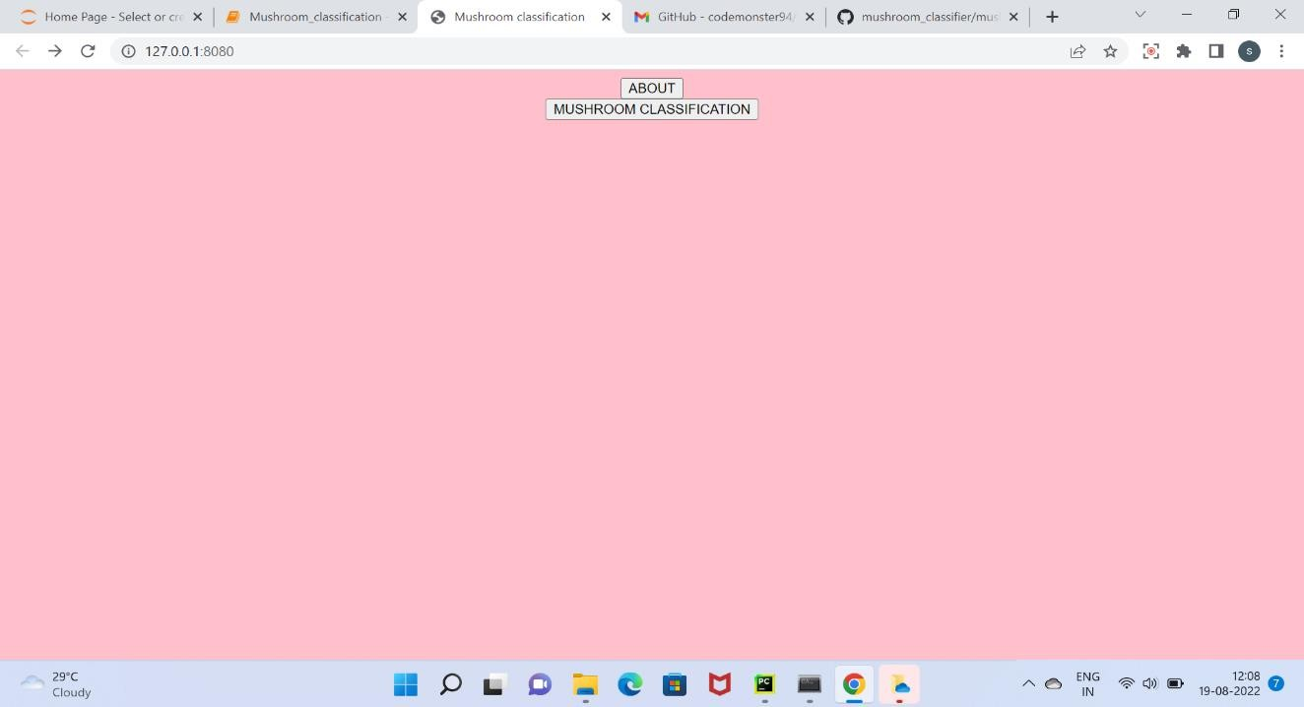

* If someone click on the About section ,then brief description will be shown of the selected topic

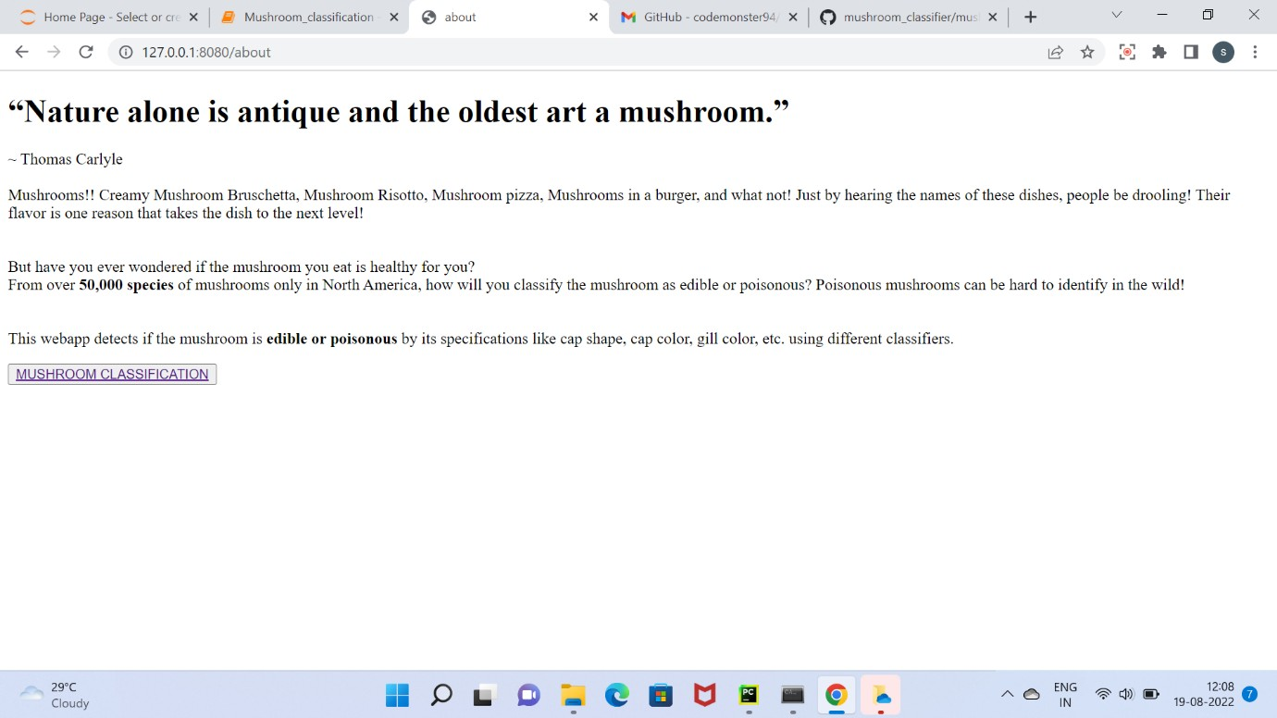

* If someone click on the Mushroom classification option then certain option will be shown that need to be filled.

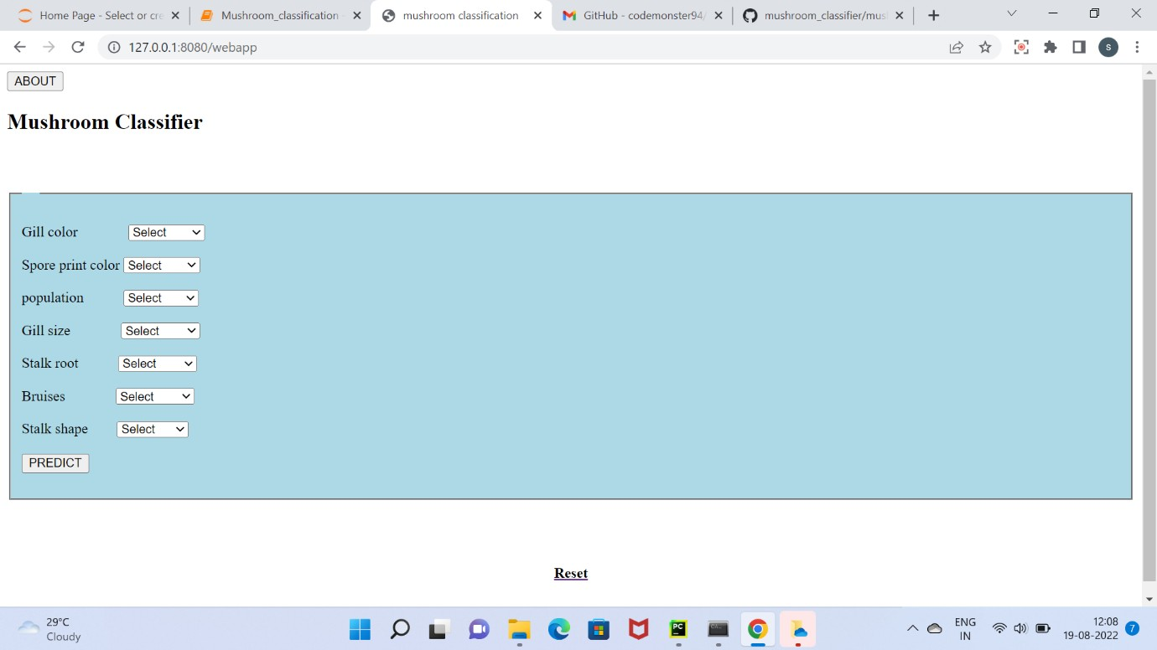

* If someone does not specify all the necessary things asked but presses the ‘predict button’,then this notification gets.

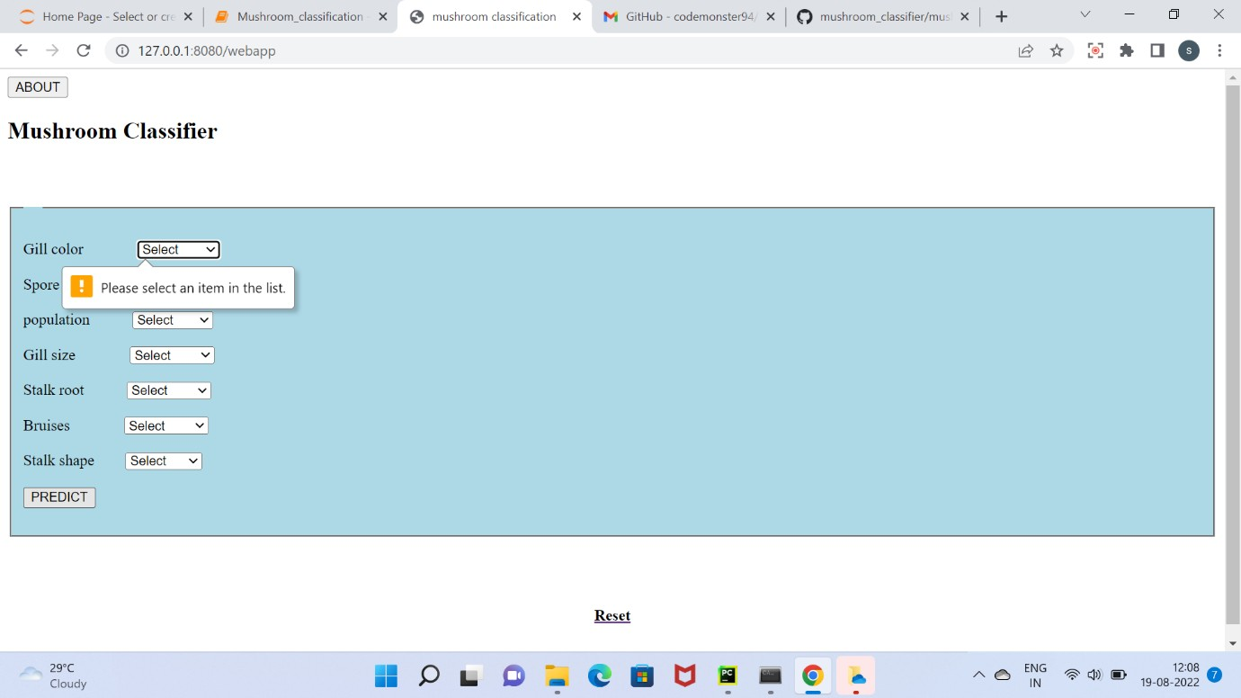

* After giving all the necessary details if you will click on the predict button ,then this interface will be getting at the window ,whether the mushroom is edible or poisonous

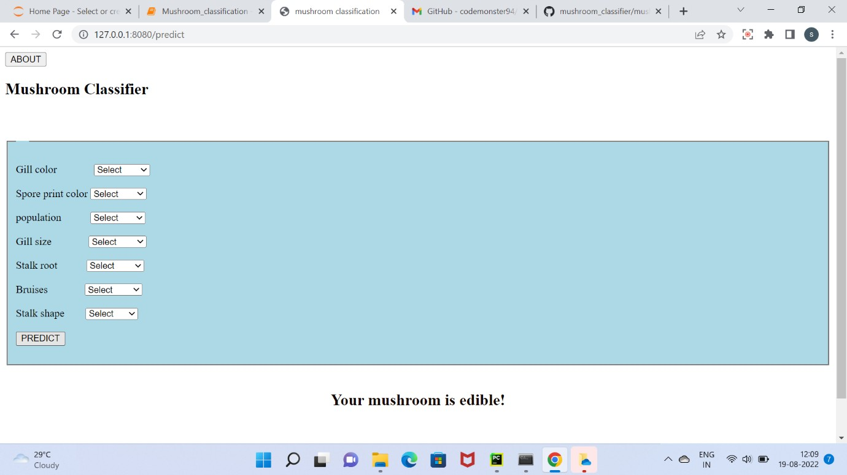

**Thanks**